**Abstract:**

This is the user manual and description of outputted files for the Visual Basic Plugin that lets users draw custom ROIs on large tiled images and then incidents those drawn shapes onto the sample using the patterned illumination system. The program assumes that you are using the 20x air objective. The DAPI filter is used when the patterned illumination is incident on the sample. Users can draw up to 5 ROIs interactively. Single or two-color tiled images can be created with a variety of tiling sizes available to choose from.

**Directions: Loading Plugin**

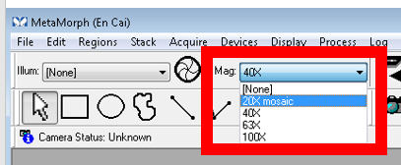

1. As soon as you enter Metamorph, please select “20x Mosaic” from the magnification menu near top of screen - see Figure 1

Figure 1: Selecting Objective

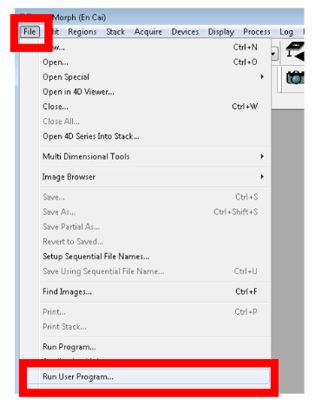

1. The visual basic plugin can be accessed through the file menu under the heading “Run User Program”- see Figure 2.

In the following window, please click “ok” and the interface of the visual basic plugin will appear. You will be not be able to use other features in Metamorph while the plugin is running.

Figure 2: Opening Visual Basic Plugin

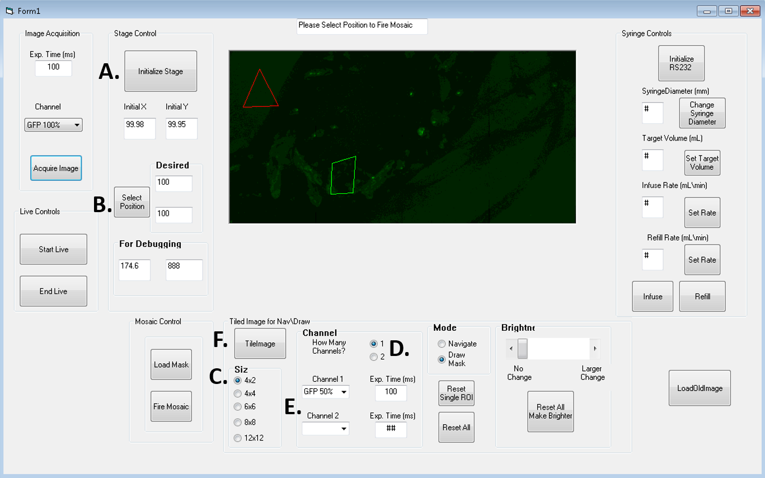**Directions: Tiling**

Figure 3: Controls for Tiling: (A) This button will mark your current position as center of tiled image. (B) This control can move the stage to desired position (C) Various sizes of tiled images are available (D) This control sets the number of channels to be acquired while tiling (E) Set here, the desired channel and exposure time for tiling

1. Move the stage (using joystick or button (Fig. 3B)) to position where you would like the center of tiled image to be
2. Press button (Fig. 3A) to set this position as center of tiled image
3. Using controls (Fig. 3C, 3D and 3E), please set the size of tiled image, the number of channels you will need and as well as the channel color and exposure time.
4. Press button in Fig. 3F to create tiled image. Tiled image will immediately appear in GUI once tiling is complete.

**Directions: Drawing Masks**

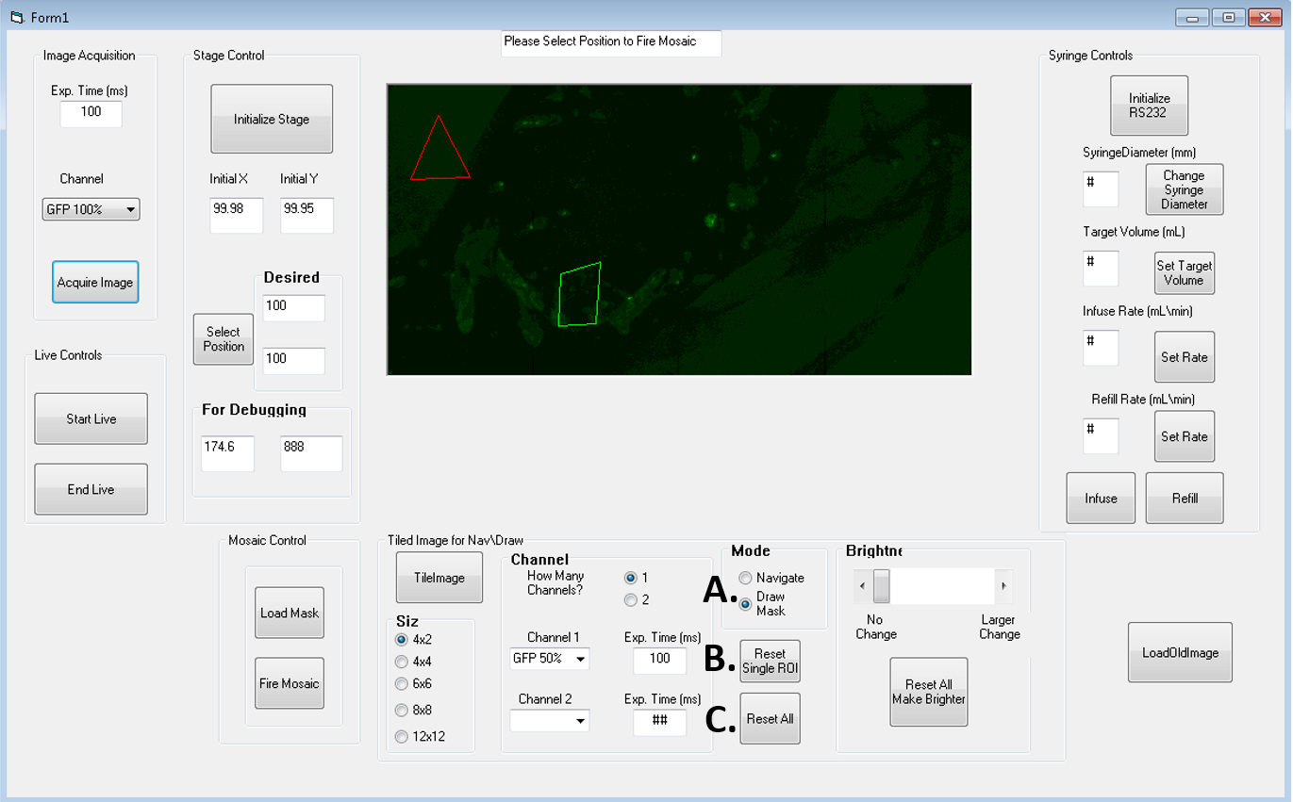

Figure 4: Drawing Masks (A) Selection button to indicate you will draw a mask (B) Button to remove the most recent ROI drawn (C) Button to remove all ROIs drawn

1. To draw masks, please begin by selecting the “Draw Mask” button shown in Figure 4A
2. Move the mouse over the tiled image. Left clicks will be the vertices of the polygon that will be your ROI. The ROI will appear as you draw.
3. Your last left click should close the ROI. Right click at this position to complete ROI and begin next ROI. The most recent ROI will appear green. Up to 5 ROIs are available.
4. The buttons shown in Figure 4B and Figure 4C will let you remove either your most recent ROI or all ROIs as you draw them
5. When you are completed, see the directions on next page to load and fire masks created by drawn ROIs using the patterned illumination system

**Note: When drawing ROIs, please insure that there are vertices (left click) in every tile in which your drawn ROI exists. In other words, feel free to use a lot of left clicks.**

**Directions: Loading and Firing Patterned Illumination**

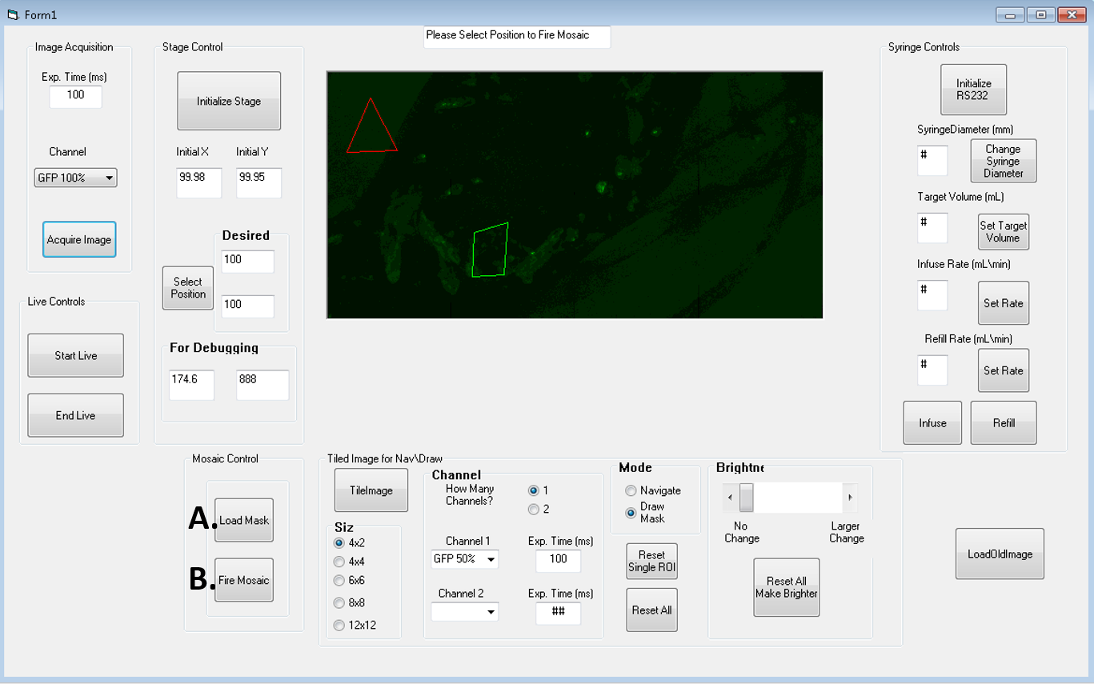

Figure 5: Loading and Firing Patterned Illumination: (A) This button will take the mask created by the drawn ROIs on the tiled image and break the mask into individual tiles (512x512) that will be given to the patterned illumination system. (B) This button will incident the individual tiles containing masks onto the sample using the patterned illumination system.

1. Once you have completed drawing your last ROI, press button in Figure 5A. This will break up the large mask created by the ROIs into the tiles that will be sent to the patterned illumination system.
2. Press the button in Figure 5B to incident masked patterns in the individual tiles onto the sample with patterned illumination system. The stage will move to the positions of each tile containing a mask, load mask, fire patterned illumination and then move on to the next tile containing a mask.

Note: Appendix 4 contains an example of a large mask (ROIs drawn on tiled image) broken up into constituent tiles.

**Directions: Loading Old Tiled Images:**

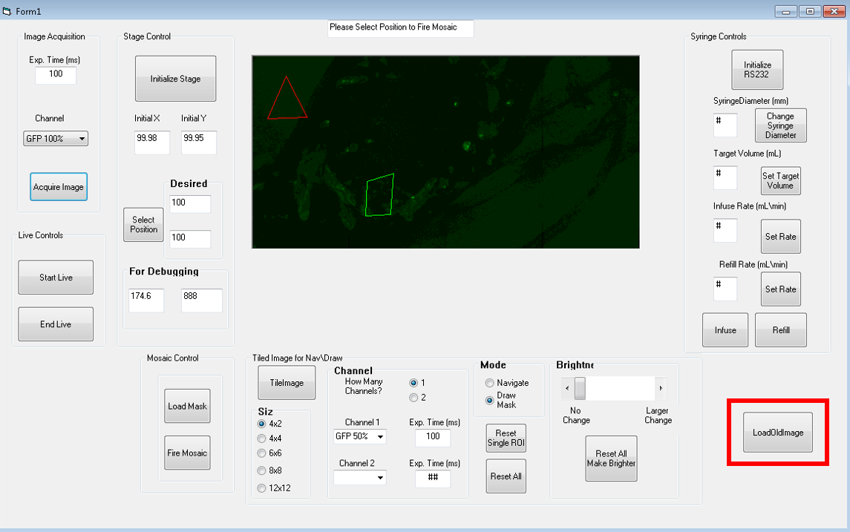

Figure 6: Button to load old tiled images

1. If the stage’s position has not been re-referenced (reset), you can use previously tiled images of your sample by clicking the button highlighted in Figure 6.
2. When the button is clicked, the software will ask you to select the text files associated with your tiled image to be re-loaded
3. You then be prompted to direct software to the tiled image you wish to use again. As a reminder, the tiled image is by default called “TileTest2.bmp” by software.
4. Once button is clicked and files selected, all relevant parameters are loaded and the stage automatically moves to the position corresponding to the center of the loaded tiled image.

Appendix 1: Description of Outputs:

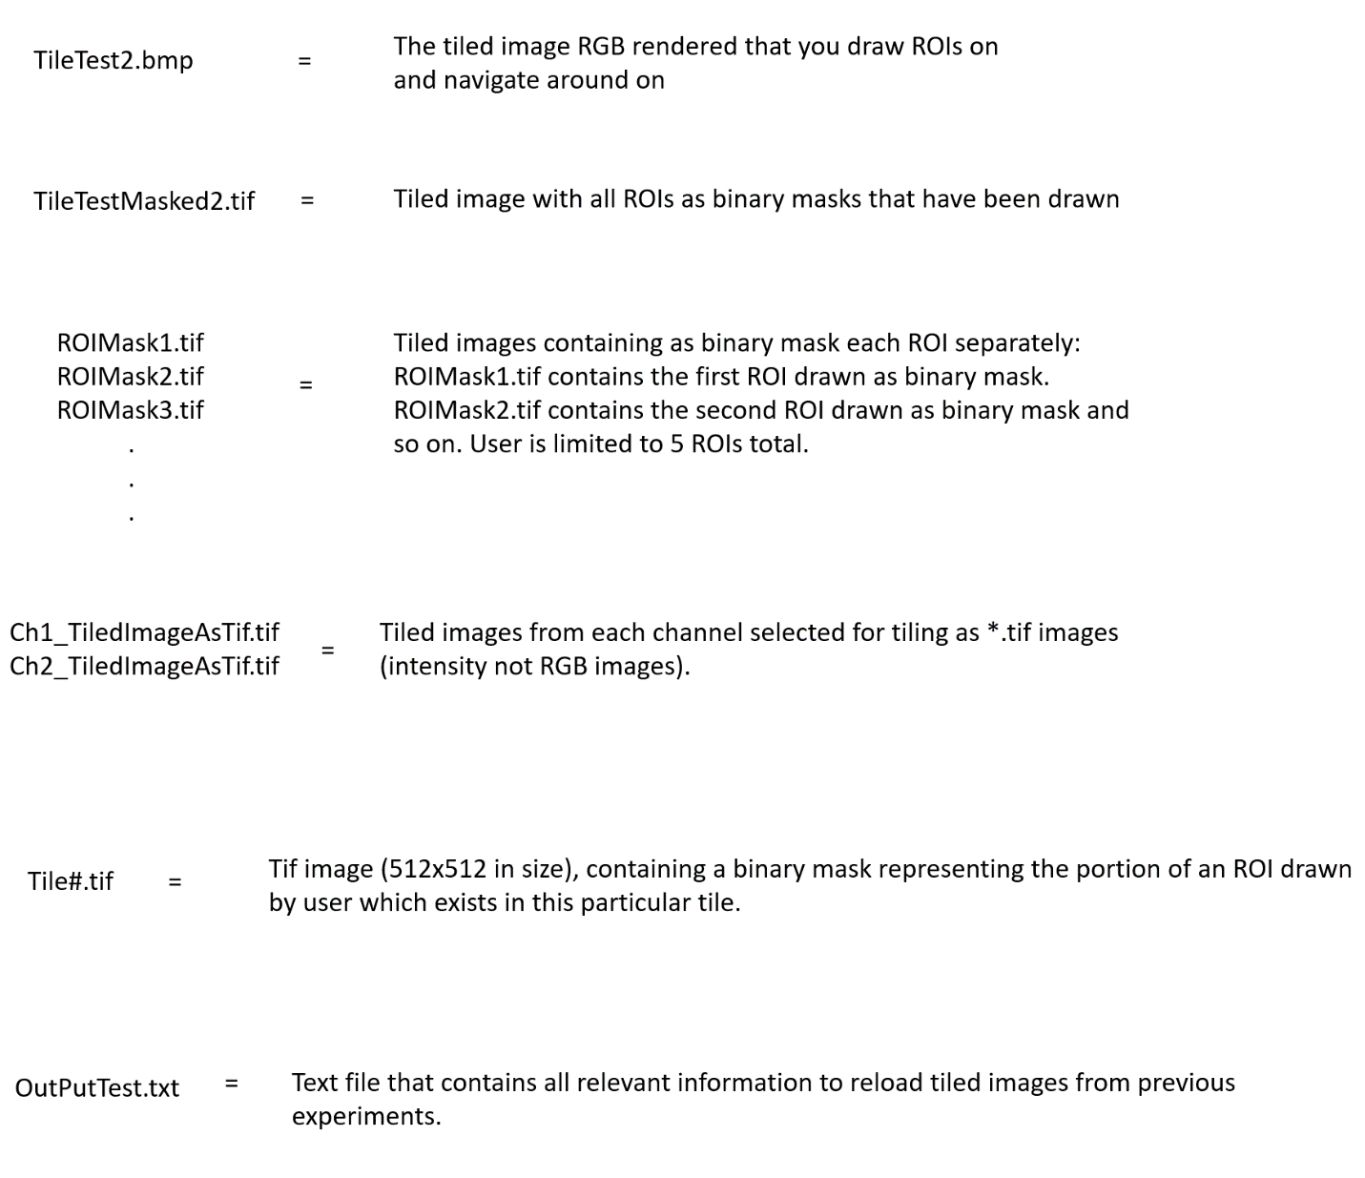

All files are by default outputted to D:\Users\John\Visual Basic Tests\

Appendix 2: Description of Tile #’s:

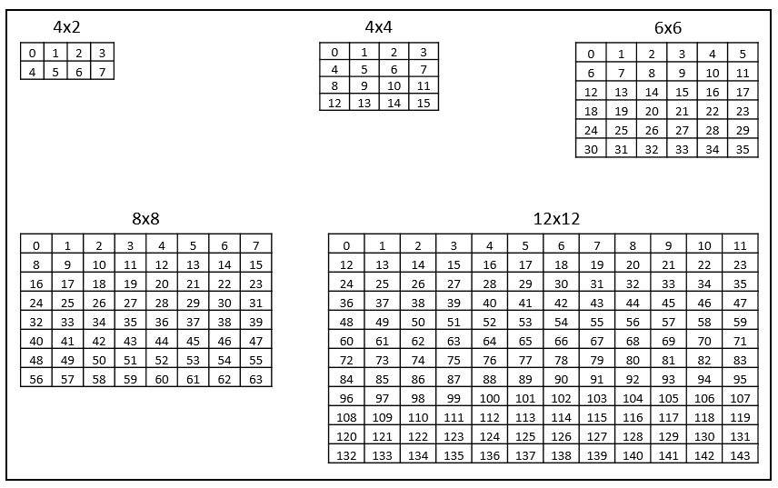

Figure 7: Tile Assignment: This is a figure showing the numbers assigned to every tile (i.e. for the files Tile#.tif) for each tiling size that can be selected.

Appendix 3: Movement of Stage During Tiling

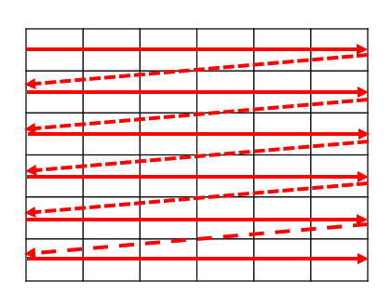

Figure 8: Movement of Stage During Tiling: Stage moves from left to right for each row of tiles. After each row is finished, the stage moves to the far left tile of the next row and begins again.

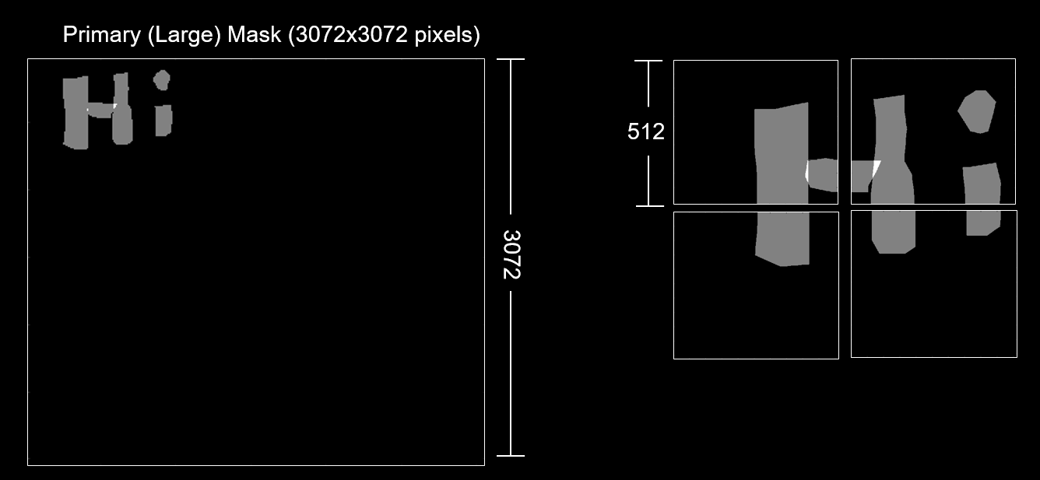Appendix 4: Example of Masks Created by Drawn ROIs

Figure 9: In left panel, there is an example of a large masked image created by a user drawing a series of the ROIs using the Visual Basic Plugin. In the right panel, the constituent tiles associated with this large mask, which will be sent to the patterned illumination system are shown.

Directions for the Visual Basic Plugin for Drawing Regions of Interest on Tiled Images to be Used With the Patterned Illumination (Mosaic) System

December 2019